PlanetCon Traffic Control tips for anyone working with car traffic at PlanetCon (including survey takers)

The role of traffic management volunteers is to:
- Direct the flow of traffic into, through and out of the event by providing directions and assistance to drivers and pedestrians
- Communicate with team members and traffic captain and help maintain an orderly traffic scene
- Most importantly, team members should not jeopardize 1) Their own safety, 2) The safety of others or 3) The credibility of the event organizers and hosts

Personal Safety is a priority: Dealing with traffic can be mentally/physically or potentially dangerous.
- Wear - reflective vest, sunglasses and hat if needed to reduce glare
- Behave appropriately and recognize personal limits; Asks for assistance or relief as needed
- Back away from dangerous situations; don’t turn your back to oncoming traffic

Communicating with drivers:
- Give clear signals and catch the eye of the person you are motioning to
- Make sure that the driver has seen and understands your signals
- Remain calm and polite; even if people become angry. Avoid escalating a tense situation.
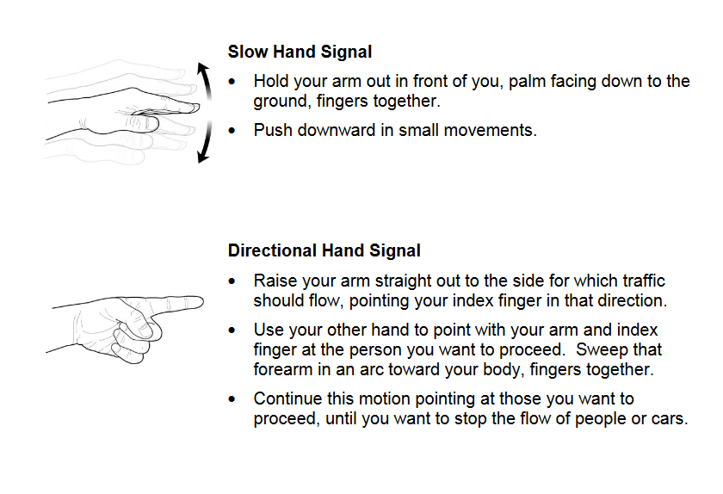
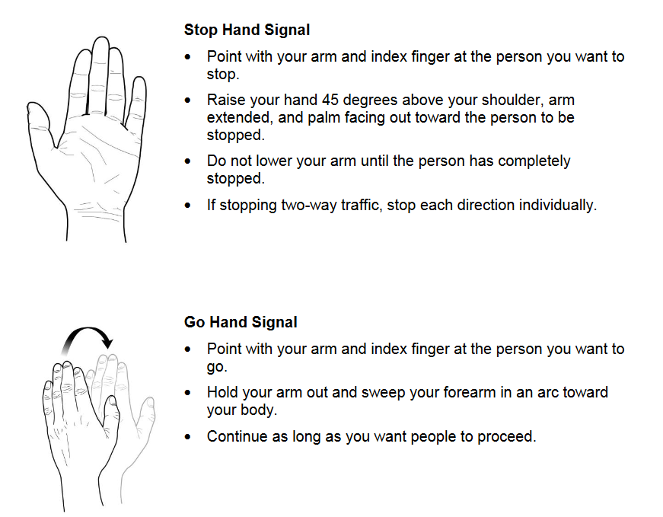

Schedule and guidance for traffic monitors and survey takers

9am – 10am
Traffic captain and volunteers: Set up pop-up tent at entrance with Entrance sign and PC sign to look like an official entrance. Lay out cones, barricades, a-frame signs and string caution tape according to map.

10am – 11am
Traffic monitor at entrance: Send cars to wait at first stop sign. We are simply lining people up double-file so all the volunteers can be in place before we officially begin the event. If you can direct folks with heavy electronics/appliances to right lane, that would be helpful, but it won’t matter much which line they get into.
Remaining traffic monitors, survey takers: Attend orientation in the building, grab safety vests, food and then head to a brief training in the parking lot.
Survey takers only (3 minimum): Get a clipboard, pen and information handouts.

11 am (or slightly earlier if everyone is ready)
Survey takers: As soon as all volunteers are ready, survey takers can start at front of lines and head down the lines. The survey includes basic questions like Zip code, Is this your first time at a PlanetCon event?, How did you hear about this event, What did you bring and Would you like to receive quarterly e-newsletter from the recycling program?
If the car does not have Styrofoam, large plastic bins or patio furniture, electronics/appliances or other items accepted in the drop-off area, send them out through one of the escape exits to the community parking lot. Survey takers can also let drivers know the next step: “Watch traffic monitor for signal to enter drop-off area and turn off car when directed”.
We will also have informational handouts you can give should people have additional questions.
Note: Survey takers are also responsible for keeping traffic flowing forward. If you see that the lane in front of you is open, move forward with the car you are surveying and wave to the cars behind you to move up.
Traffic monitor at entrance: Wave cars through. If right-turn lane is preventing left-turn lane from entering, stop right-turn lane to allow left-turners to enter. This will be your judgement as to when this is needed. Everyone enters and gets surveyed – no one gets to skip the line.
Traffic monitors at entrance and exit of drop zone: Let in 8 vehicles at a time, direct them to turn off vehicle before unloading. Volunteers will help transport items to appropriate areas but aren’t responsible for opening trunks or doors. Styrofoam/plastic volunteers can also remind drivers to turn off car. They also can let drivers know to watch for traffic person for signal and that the exit is to the left of the school. Once volunteers are out of the way, traffic person can direct cars through exit into community parking area or point out the exit on the left side of school. Front cars first of course, one at a time, without weaving in and out. Then direct the next 8 vehicles into the drop-off area.

